|  |
| --- |
| Background Information Document |

|  |
| --- |
| **Proposed Exploration Well Drilling in PEL 82 covering Blocks 2112B and 2212A, Walvis Basin, off the Coast of Southern Namibia**  Chevron Namibia Exploration II Limited |
|  |
| **Purpose of the Document**  Chevron Namibia Exploration Limited II (CNEL) is compiling a suite of regulatory documents to facilitate the approval process for an Environmental Clearance Certificate (ECC) for its proposed exploration programme (i.e. proposed project) under Petroleum Exploration License (PEL) 82 in the Walvis Basin, offshore Namibia.  The proposed project triggers activities outlined in Government Notice No. 29 of the Environmental Impact Assessment (EIA) Regulations 2012, issued under Section 56 of the Environmental Management Act, 2007 (No. 30 of 2007) (EMA). Consequently, it necessitates obtaining an ECC from the Ministry of Environment and Tourism (MET), the regulatory authority, before commencing any activities. An EIA process must be conducted for Ministry of Mines, Energy and Industry, as the competent authority, to evaluate the ECC application. |

# Project Background

Chevron Namibia Exploration Limited II (CNEL) plans to initiate an offshore exploration program within Petroleum Exploration License (PEL) 82 encompassing blocks 2112B and 2212A, situated in the Walvis Basin, Namibia. The license area spans approximately 11,400 km², located between 80 km and 300 km offshore, with water depths ranging from 200 m to 2,500 m (Figure 1). The exploration activities may include:

1. Drilling up to five exploration wells in to-be-determined locations, including drilling, deepening, or sidetracking, and testing and completing the wells.
2. Drilling up to five appraisal wells, including drilling, deepening, or sidetracking, and testing and completing these appraisal wells.
3. Conducting Vertical Seismic Profiling (VSP).
4. Performing well testing.
5. Plugging and abandonment of wells offshore.

Figure 1 Project Locality

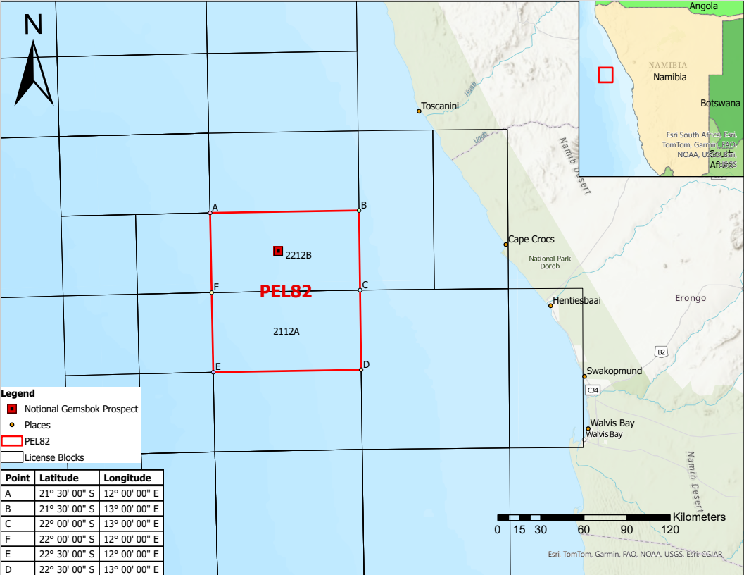

These activities will utilize Mobile Offshore Drilling Units (MODU) drillships. Initially, the plan is to conduct a one well campaign between Q2 2026 and Q1 2027, in the Gemsbok prospect location (coordinates: LAT: 21° 44’ 48.15” S, LONG: 12° 27’ 13.74” E; with water depths ranging from 1,000 – 1,500 m. If successful, potential follow-up drilling could include up to nine additional wells (total of 5 exploration and 5 appraisal wells) in the blocks in 2027 and beyond. The drilling of one well is expected to take in the order of two to three months to complete.

Figure 2 Examples of MODU drillship and activities associated with the drillship

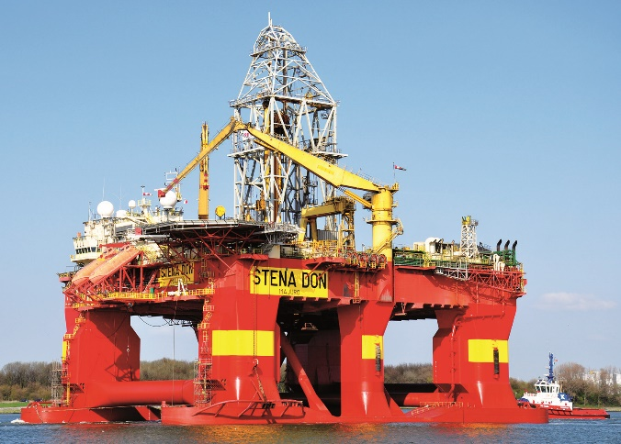 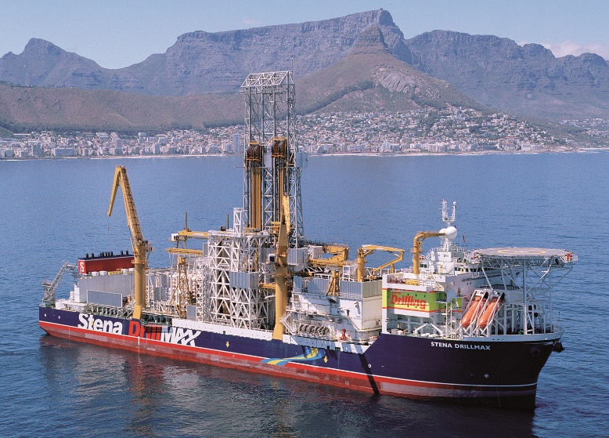

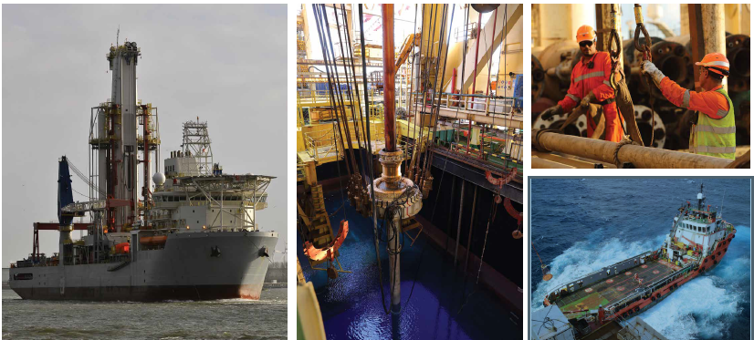

# Environmental and Social Impact Assessment Process

The Environmental and Social Impact Assessment (ESIA) process involves identifying and evaluating the potential positive and negative impacts of the project, in collaboration with Interested and/or Affected Parties (I&APs). It also determines the necessary management measures to mitigate or reduce these impacts to an acceptable level. The process is divided into two main phases: the Scoping Phase and the Impact Assessment Phase, as illustrated in Figure 3. Currently, this ESIA process is in the Scoping Phase.

Figure 3 ESIA process in Namibia

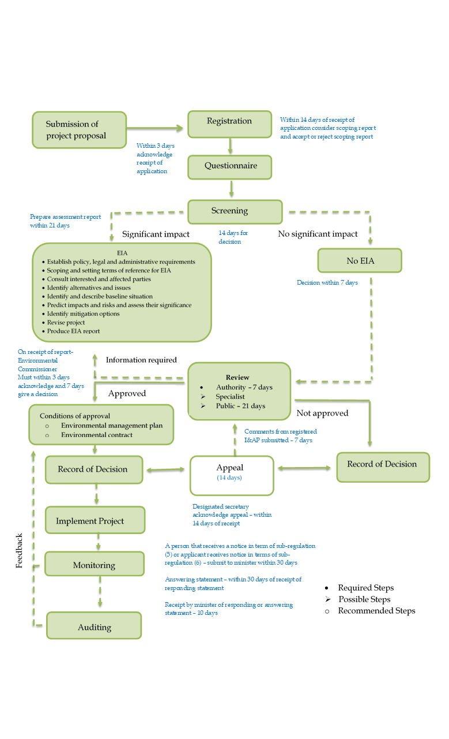

# ERM’s Role

CNEL has appointed Environmental Resources Management (ERM) as the independent environmental consulting company to conduct the ESIA process. ERM is supported by a Namibian firm, Urban Dynamics Africa (Pty) Ltd, to manage the stakeholder engagement process.

## Register as an Interested and/or Affected Party

If you are an I&AP, please consider:

* Registration on the project database.
* Participate in upcoming engagements.
* Review and provide feedback on the draft reports when they are made available to the public.

|  |
| --- |
| For further information and for registration: |
| Register at: QR code above or at link below  [https://forms.office.com/Pages/DesignPageV2.aspx?subpage=design&FormId=DQSIkWdsW0yxEjajBLZtrQAAAAAAAAAAAANAAb_mI3xUMVFVR1paNU5UVktLUE1DU1pLNzBTQlVLNC4u&Token=cc818f03f9b44c56aac392c0c266c73a](https://eur01.safelinks.protection.outlook.com/?url=https%3A%2F%2Fforms.office.com%2FPages%2FDesignPageV2.aspx%3Fsubpage%3Ddesign%26FormId%3DDQSIkWdsW0yxEjajBLZtrQAAAAAAAAAAAANAAb_mI3xUMVFVR1paNU5UVktLUE1DU1pLNzBTQlVLNC4u%26Token%3Dcc818f03f9b44c56aac392c0c266c73a&data=05%7C02%7CAnathi.Manyakanyaka%40erm.com%7C69b1b179b0ff4bca83b708dd75a473ba%7Cf2fe6bd39c4a485bae69e18820a88130%7C0%7C0%7C638796071558328553%7CUnknown%7CTWFpbGZsb3d8eyJFbXB0eU1hcGkiOnRydWUsIlYiOiIwLjAuMDAwMCIsIlAiOiJXaW4zMiIsIkFOIjoiTWFpbCIsIldUIjoyfQ%3D%3D%7C0%7C%7C%7C&sdata=0zfeGPUWj4ZnwcA907Mltsz6YhLq8jJUrnTfcvaZfbk%3D&reserved=0)  Telephone outlineTel: +264 61 240 300  Email with solid fillEmail: [cnel.pel82esia@erm.com](mailto:cnel.pel82esia@erm.com)  Internet outlineProject website: [www.erm.com/cnel-esia](http://www.erm.com/cnel-esia) |